# **2.0 Design Evolution**

## This chapter gives an insight into the design that is proposed for this project. A detailed breakdown of the initial design and how it would develop in the future. It also mentions how it is provided and evaluated against how it meets the project criteria for success, as well as its drawbacks.

## **2.1 Design: Data 2 Intelligence Webpage**

This design was created for the project before the first consultation occurred to determine requirements. The name was conceptualized by capturing the process data scientists perform, at a very general level, which is converting and consolidating data into recognizable patterns and useable metrics.

The design of this webpage will change as the project develops throughout its lifecycle. Therefore, we will analyze the current stage of the websites design, as well as the future designs and additions that will be made.

### **2.1.1 Description of Current Stage [Data 2 Intelligence] [Level 3]**

The design is a website which is used both for data scientists to submit their data electronically, as well as a reference for any users looking to replicate this process on their own. Acceptable formats of data are limited to include only CSV file formats at this time. The data received will then be entered into a database. The server would then perform various operations on the data and if the process was successful, the data would then be passed to the D3 and DC libraries to generate visual representations of the data in a new window.

The side menu would be the user’s main method of navigation through the website, with the ability to upload their data using the bottom button of the menu. Users can also view descriptions of different types of analysis, different Python libraries, and programmer pages to detail to the user different roadblocks or difficulties faced during this implementation, which will be periodically updated by each developer.

The top menu bar will be the users main resource tab to access throughout the use of the website. This menu allows the user to access all the main resources that is used to build the application, the user can find additional information on what tools and libraries that were vital to the development of the application and become stronger data scientists along the way.

A detailed photo of the website’s homepage can be seen in Figure 1.

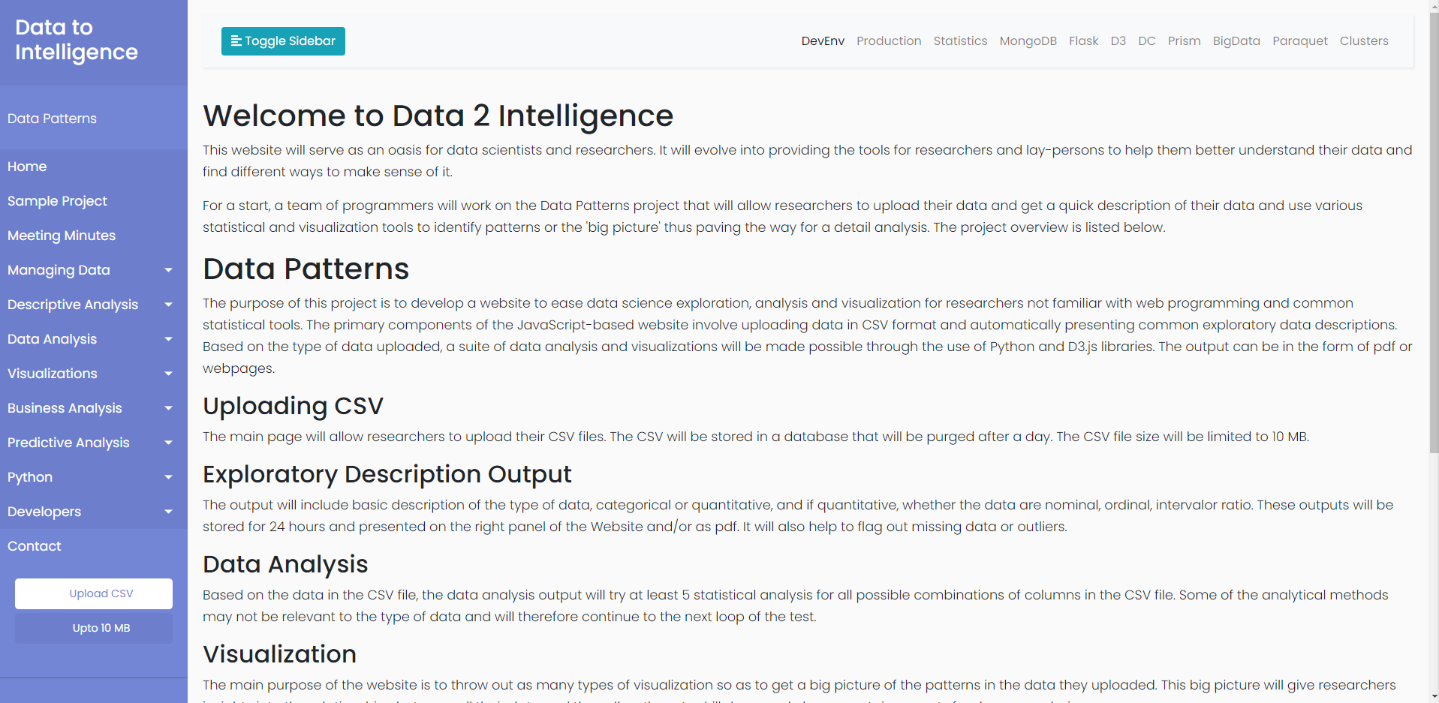

Button to upload data to the database Resource Bar Tab for developers to detail progress Figure 1: The home page of Data 2 Intelligence

### **2.1.2 Evaluation of Current Design [Data 2 Intelligence] [Level 3]**

### The side menu used in this design was a good choice as it allows the user to view their main menu options from any page. This allows for easy navigation, as well as uninterrupted viewing of the generated charts and graphs from the user’s data. This design lends itself well aesthetically to support the use of the D3 and DC libraries, as well as running on the Flask engine.

The top menu is a great addition to transform the website into a learning experience while using its main features. We are making the assumption that the user is at a very low level of understating in regards to data science, so providing them with these resources will allow them to enhance their knowledge in this particular field.

One of the main issues in this design is the “Upload CSV button”. If other file types were to be added support for, this design would need to change to a sub-menu to determine which type of data is being submitted by the user.

Another issue is support for multiple users at once. With the Upload CSV button being a button that is just a static button, there runs the risk of data collision between different users. There is not presently a way for users to ensure that their data is not being contaminated by another user adding their dataset to the Mongo database.

### **2.1.3 Future Changes of Design [Design Data 2 Intelligence] [Level 3]**

Since the design was created, there has been minor modifications made, but everything has stayed relatively the same. The architectural design will not change at all as the project develops in the future, however the following will showcase some modifications that can expect to make in the future.

### The side menu used in this design was a good choice and will not be changed in a future design of the website. However, some modifications may be made to the color, options and names of each dropdown option.

The top menu will most likely remain unchanged, and no severe changes will be made to the look and feel of it. As for modifications, if we decide to change/add new resources to the development of the project. We will add those specific sections to the top menu bar.

### As for the “Upload CSV” button. In a future stage of the project, the website will have the ability to add multiple file types to the database. The buttons design will be altered to say “Upload” instead.

## **2.2 Comparison of Design According to the Project Criteria**

The following Table compares both stages of the Data 2 Intelligence website design to the project criteria.

**Table 1: Comparison of Design According to the Project Criteria**

|  |  |  |  |
| --- | --- | --- | --- |
| **Criteria** | | **Data 2 Intelligence Current Stage** | **Data 2 Intelligence Future Stage** |
| 1 | Development must be done in Ubuntu 21.04 | YES | YES |
| 2 | The websites backend will utilize Python 3.8.5 | YES | YES |
| 3 | Flask will be used to deploy JavaScript Framework | YES | YES |
| 4 | The Application will use MongoDB (Database that can store unstructured data) | YES | YES |
| 5 | The front end of the application will consist of D3.js & DC.js libraries. | YES | YES |
| 6 | Be able to manage our time efficiently while setting effective timelines for each agile sprint. | YES | YES |
| 7 | Incorporate different types of visualizations to meet different types of requirements. | YES | YES |
| 8 | Incorporate functionality to be able to extract data into different types of outputs. | YES | YES |
| 9 | Future criteria Requests from the client | NO | YES |
|  | TOTAL | 8/9 | 9/9 |

Based on the fact that the Initial design was provided to use, when we compare it to the project criteria, this design already meets all of the project criteria requirements that are listed. However, throughout the projects life cycle, there may be new criteria that is requested and others that may need to be altered. Knowing this, it is safe to assume that any future design changes that must be made will meet the new deliverables and criteria that is requested.